**CST-361 - Design Report Template**

|  |  |  |
| --- | --- | --- |
| **Topic:** | Project Milestone 4 | |
| **Date:** | February 11, 2019 | |
| **Revision:** | 4.0 | |
| **Team:** | Fredrick Onduso Ondieki | |
|
| **Weekly Team Status Summary:** | |  |  |  |  | | --- | --- | --- | --- | | **User Story** | **Team**  **Member** | **Hours**  **Worked** | **Hours Remaining** | | Update project management goals, aims, and tasks from the earlier version of application | Fredrick Ondieki | 2.0 | 1.0 | | Redesigned the project from web application to revolve to IoT application using all aspects of IoT | Fredrick Ondieki | 2.5 | 0.25 | | Updated the project to include design patterns learned in class for instance the component design pattern | Fredrick Ondieki | 1.25 | 1.0 | | Changed the design of the UML diagrams | Fredrick Ondieki | 2.0 | 1.0 | | Developed the design of the application and the user interface. | Fredrick Ondieki | 1.0 |  | | Updated the ER diagram and Wireframes | Fredrick Ondieki | 2.50 | .25 | | |
| **GIT URL:** | https://github.com/FREDDYSMALLZ/TheWeatherApplication | |
| **Peer Review:** | Y | Yes. I acknowledge that I have reviewed this report and have agreed to the approach that I will be taking. |

**Planning Documentation**

**Agile Retrospective Results:**

|  |
| --- |
| **What Went Well** |
| Successfully developed the bean classes for the user and for the weather. |
| Successfully integrated the database part to the project |
| Successfully developed the JSF pages for interaction purposes. |
| Successfully used the patterns learned in class to the project: Singleton pattern |

|  |  |  |
| --- | --- | --- |
| **What Did Not Go Well** | **Action Plan** | **Due Date** |
| Executing the project encounters error in loading the project despite having the .war file. | Recheck the web.xml file and may be change the project start-up file | February 11, 2019 |
| The error page from executing the page is included on the screenshot bellow showing a 404 error | I have the page displayed as missing and thus will have to recheck what part is missing. | February 11, 2019 |
| Error in connecting the application to the database. There is an error in the connection pool | Check the MySQL connector file version and change it | February 11, 2019 |

**Design Documentation**

**Install Instructions:**

* Used MySQL relational database in this project. Added one database “WeatherDb” with two tables “userTbl” and “weatherTbl” to handle the project data.
* Used Apache Tomcat Server Version 9.0.14 version
* Used IntelliJ IDEA as the development environment

**Known Issues:**

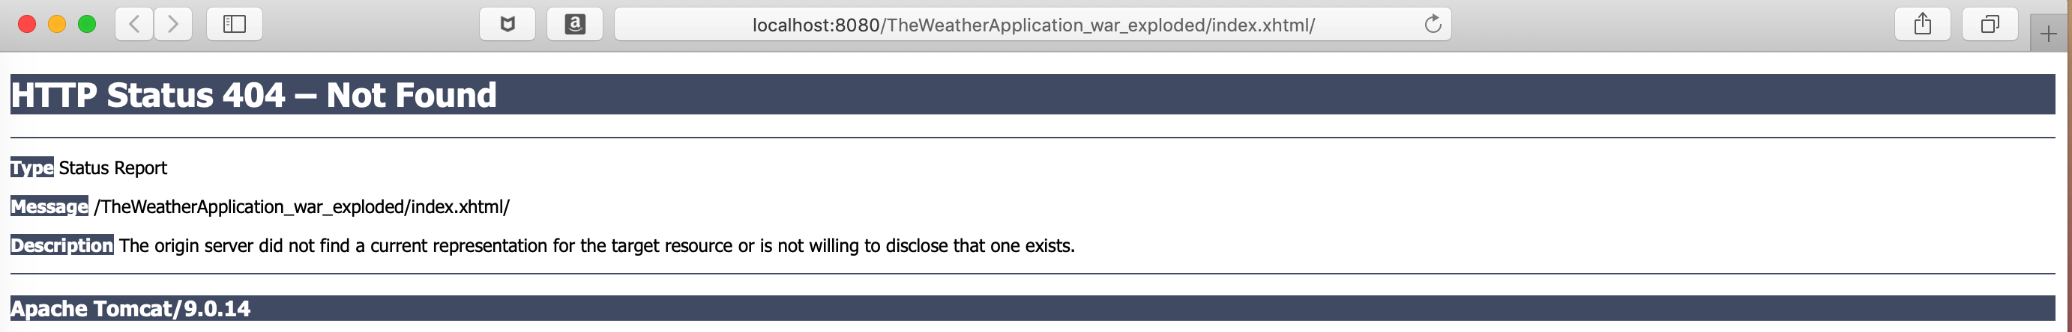As mentioned above, I had a problem in executing the program. After the program execution, there is a 404 error in loading the index.xhtml file. Secondly, there was an error in connecting to the database.

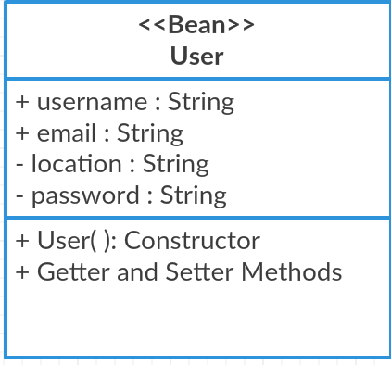**Class Diagrams:**

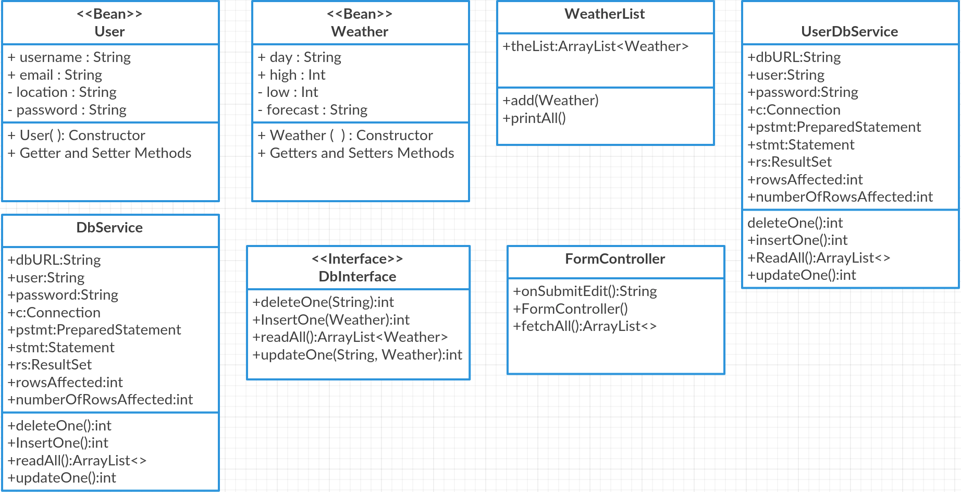

**Pseudo Code:**

https://github.com/FREDDYSMALLZ/TheWeatherApplication

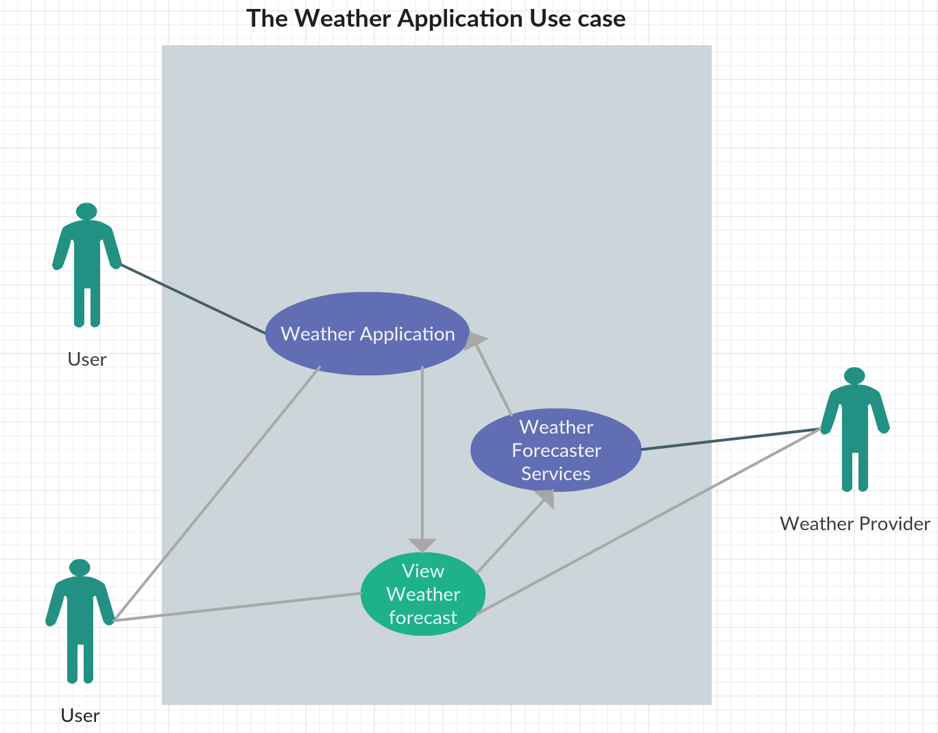**Other Documentation:**

